**Session report 09 /12/2022:**

*LABAUVIE – RAFFAELLI EVA*

*ROB3*

The goal of today’s session is to get most of the conception about the sorting device done, and start bringing it to life.

The first idea was to use a grid to scrape the sand and collect the rubbish, then lift this grid so the rubbish got to fall on the conveyor. Once on the conveyor, the rubbish could be stopped in front of the camera, recognized, and then either be pushed into a tray or just left on the conveyor until it falls back outside the robot at the end of the conveyor.

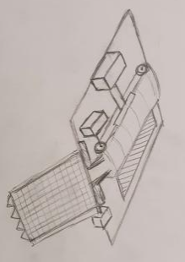

After discussing with Mr. Peter, we decided to change the grid system for a wheel system.

We inspired ourselves with a wheel used in the drilling field, like this one :

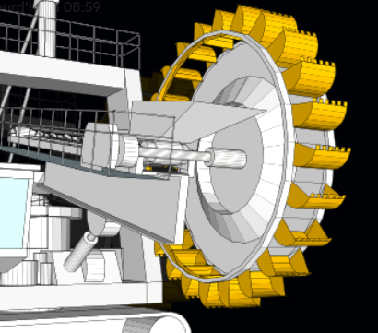

It is empty inside, so we can put a collecting device to collect the rubbish, and redirect them on the conveyor.

We just intend to make the bucket made like a mesh, so the sand isn’t collected (either by using directly a mesh, or by aligning some nails into a comb like piece).

So now, it would most likely look like that :

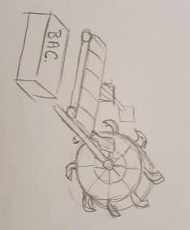

With the same system on the sorting part.

About the sorting part here :

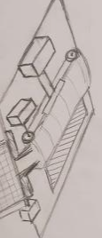

The circled part will work like a piston to push the rubbish into a tray (here, in the blue zone), powered by a servo-motor.

I will start by trying to make this piston piece for the sorting. I decided to try a rack and pignon system.

I started by modelling them on Fusion 360.

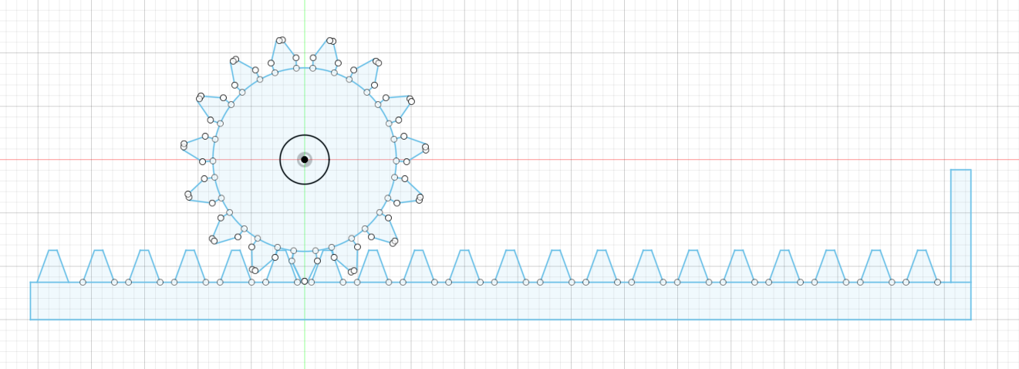

Then, before trying any 3D printing, I wanted to try cutting a first job on the laser-cutting device, to verify it works the right way and adjust.

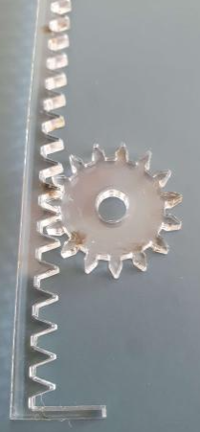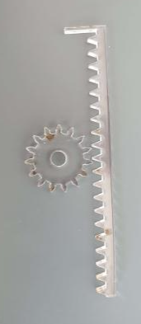

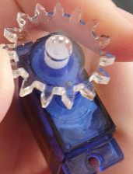

It worked, since the pignon and rack are working together perfectly. The only issue is that I did not take enough margin into consideration for the part supposed to match the servo motor (circled in red).

I will need to make another pignon with more space to fit the servo motor, and maybe change the attach system.